|  |
| --- |
|  |
| SUBMMITTED BY, |
|  |
| DIVAGAR R |
| au812921106010  divagar864@gmail.com |
|  |
|  |
|  |

**FLOOD MONITORING**

AND EARLY WARNING SYSTEM

Introduction

A Flood Monitoring and Early Warning System (FMEWS) is a comprehensive infrastructure designed to detect, monitor, and provide timely alerts about potential or ongoing flood events. Its primary objective is to mitigate the impact of floods on communities, infrastructure, and the environment. This system employs a combination of sensors, data processing units, communication networks, and decision support systems to gather, analyze, and disseminate critical information related to water levels, weather conditions, and potential flood risks.

Block diagram

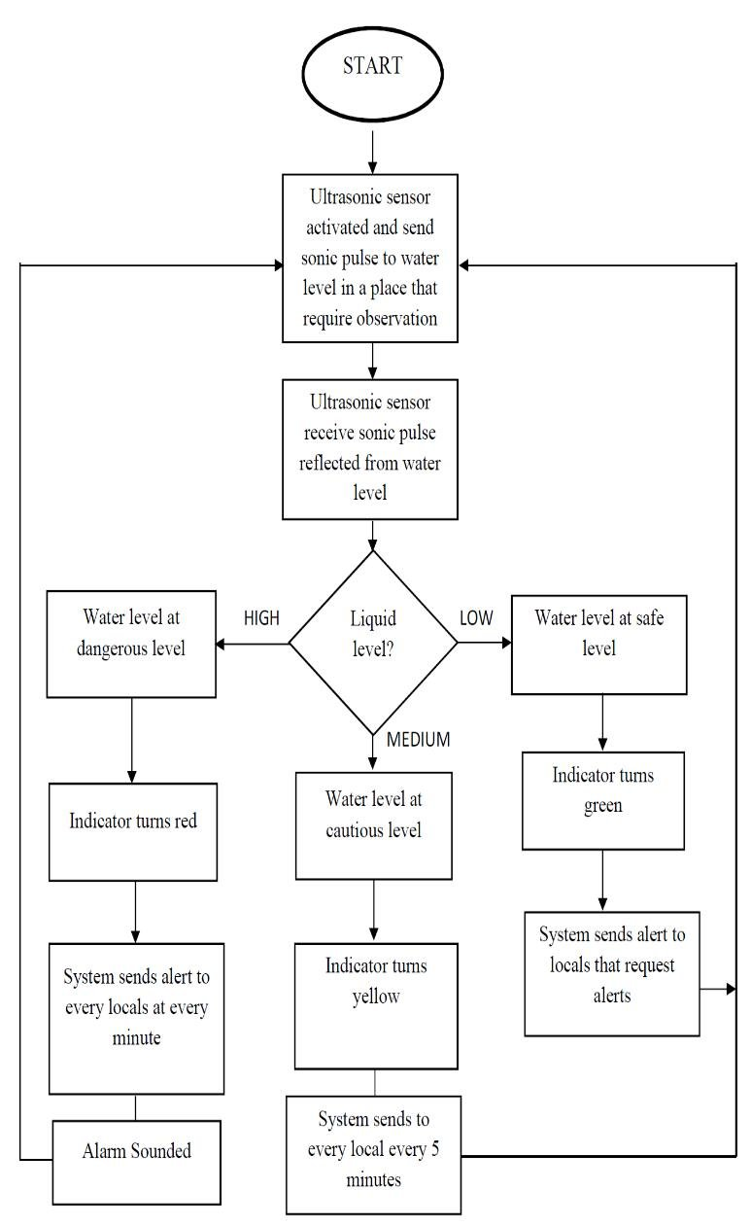

Components

* Arduino
* Buzzer
* GMS module
* Node MCU
* Water level sensor

1. Arduino:

Arduino is a single-board microcontroller that is widely used to create various types of digital devices, block diagram shown in Figure. You can control and interact with variouselectronics components such as sensors, actuators and much more. It has its own fixed RAM and stores data quickly memory and EEPROM. It uses languages such as C, C ++, and Java.

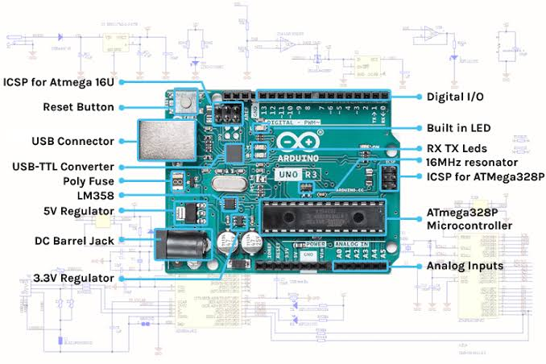

2)Buzzer:

Buzzer or Beeper is an audio signing tool, which can be mechanical, electromechanical, or 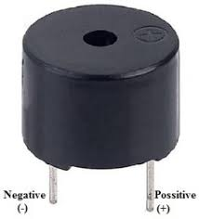piezoelectric. Buzzer and beepers is widely used in include alarm devices, timers, and user input verification

## 3)GSM Module:

GSM module is a hardware device that uses telephony technology to provide a data connection in a remote network. From a mobile phone network view, they look exactly like a normal cell phone, including the need for a self-identifying SIM network. GSM modems typically provide a TTL-level serial interface to their Host. They are often used as part of an embedded system.

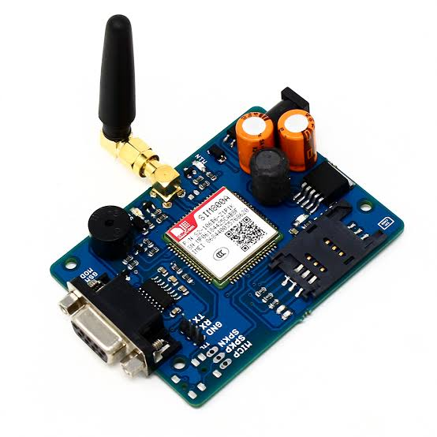

4)NodeMCU:

NodeMCU is an inexpensive open source platform. Originally included firmware running on ESP8266 Wi-Fi SoC from Espress if Systems, as well as Hardware based module ESP 12.Later, support for ESP32 32-bit MCU was added

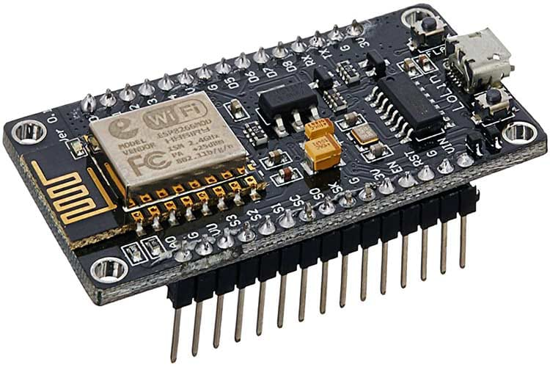

5)Water Level Sensor:

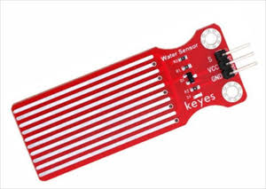 A water level sensor is a sensor that relays information back to a control panel to indicate whether a body of water has a high or low water level. The water level sensor employs a simple mechanism to detect and indicate the water level in an overhead tank or any other water container according to Electronic Hub.

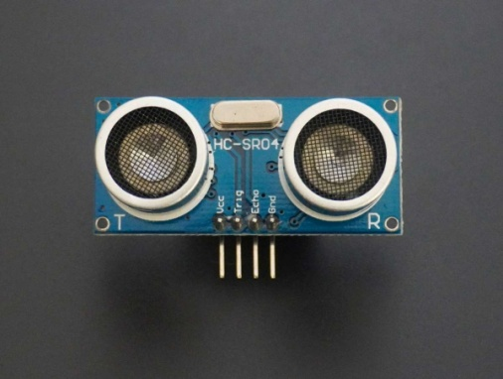

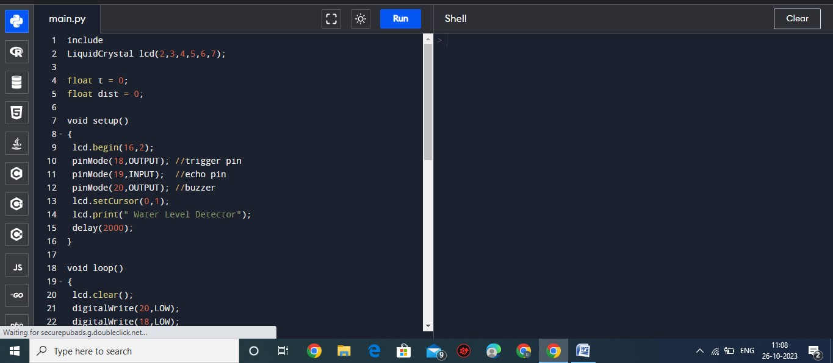pragram

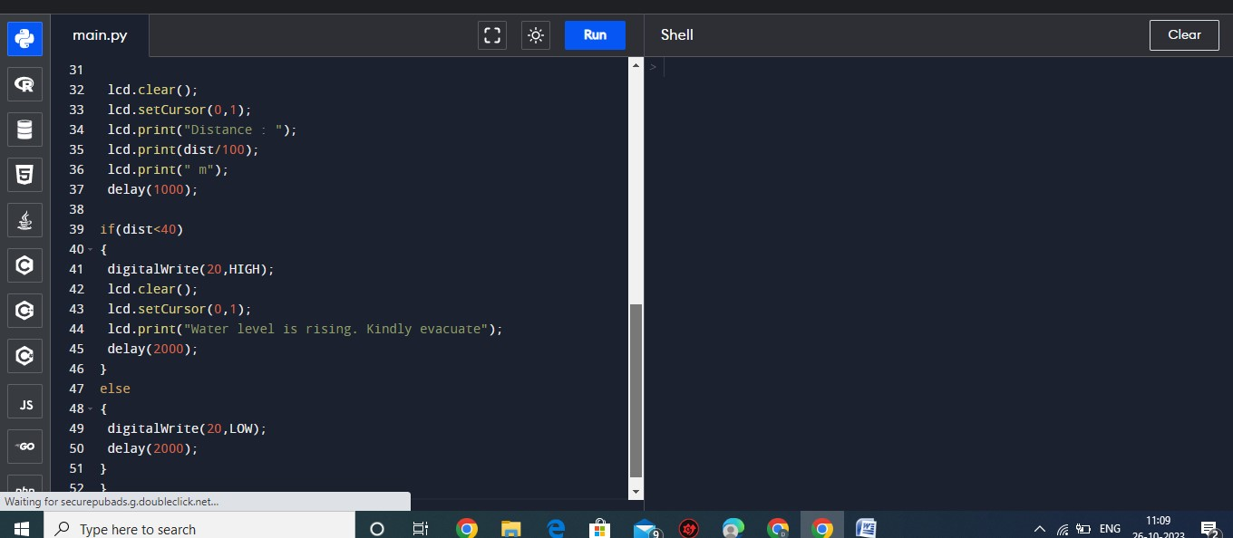

output